Name:- Brijesh Ramoliya

Roll No:- 91900133025

Title:- Hotel Management system

Sem:- 5

Branch:- B.TECH ICT

Subject:- DBMS

Subject Code:- 01CT0502

* 1. Abstract [10-15 lines]
* 2. Schema Diagram
* 3. E-R Diagram [Cardinality constraints]
* 4. Schema Designing
* 5. Database in pgadmin [project_rollno]
  + All the tables, keys, data, queries[5-10queries]
* 6. Snapshots[TABLES AND QUERIES]
* 7. Conclusion [5 lines]
* All the tables and queries one sql file.
* .zip [pdf of report and .sql file]

1)Abstract.

* In this project on Hotel Management System, we have a tried to show how to the data and information in Hotel Managed. In this project are very useful in customer and hotel owner. Customer can see every detail in every room and hotel management system service is good or not good. Every detail in safe in customer. I have a create a table in database . this table input every detail in like customer, waiter, Master safe, cleaning staff and guard. Table is created, after Table created every detail in input in database system. Hotel Management System is best Management System. All data are covered in My data. I have a draw schema diagram and E-R diagram. And last I have a create Schema Designing. And last I have a create a database server and put the all value.

2) Schema Diagram.

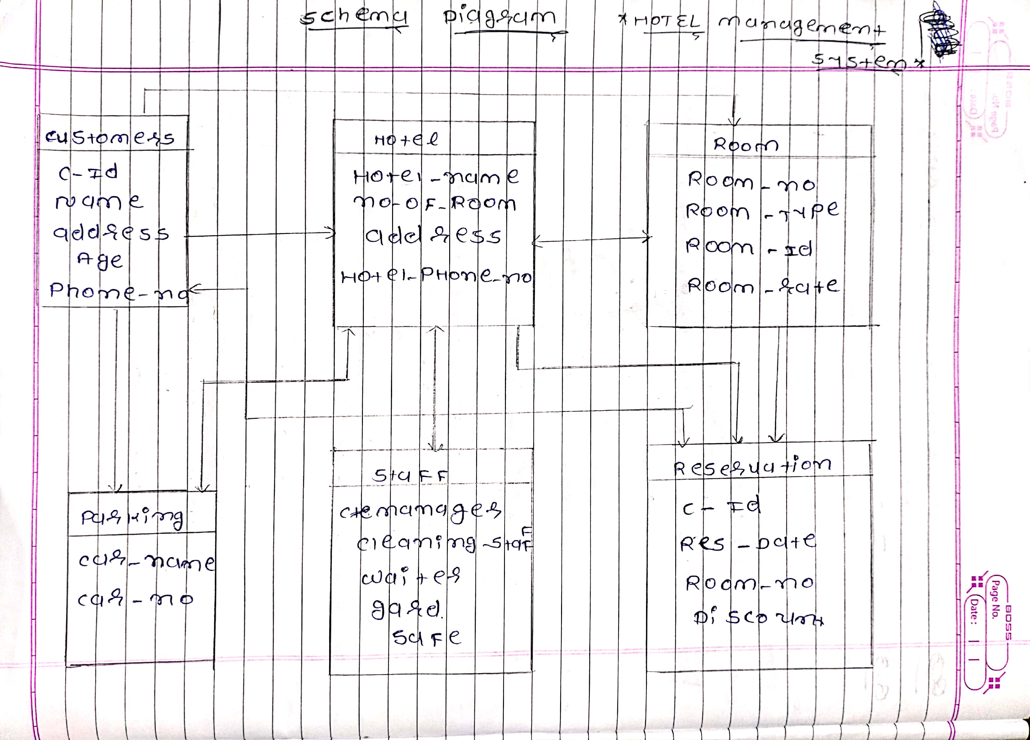

3) E-R Diagram [Cardinality constraints].

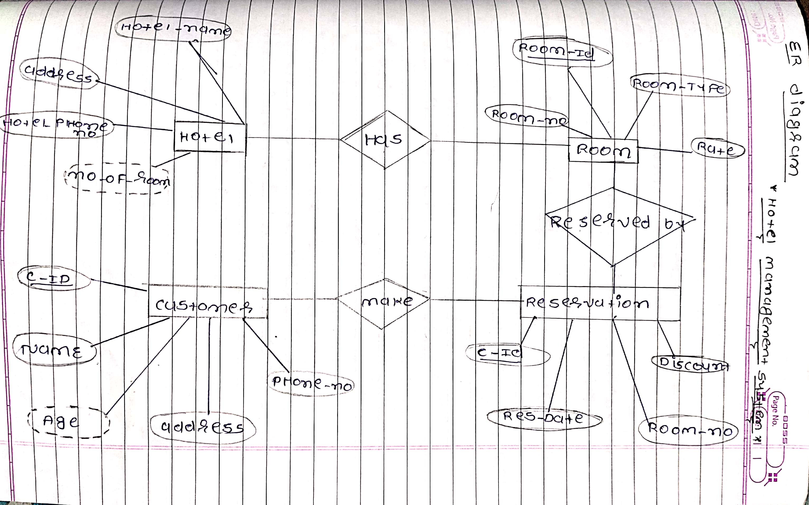

4) Schema Designing.

Hotel(Hotel_name,Address,Hotel phone no,No_of_room)

Customer(c_ID,Name,Age,Address,Phone_no)

Room(Room_ID,Room_no,Room_type,Rate)

Reservation(C_ID,Res_Date,Room_no,Discount)

6) Snapshots [TABLES AND QUERIES].

TABLE:-

[1] Customers

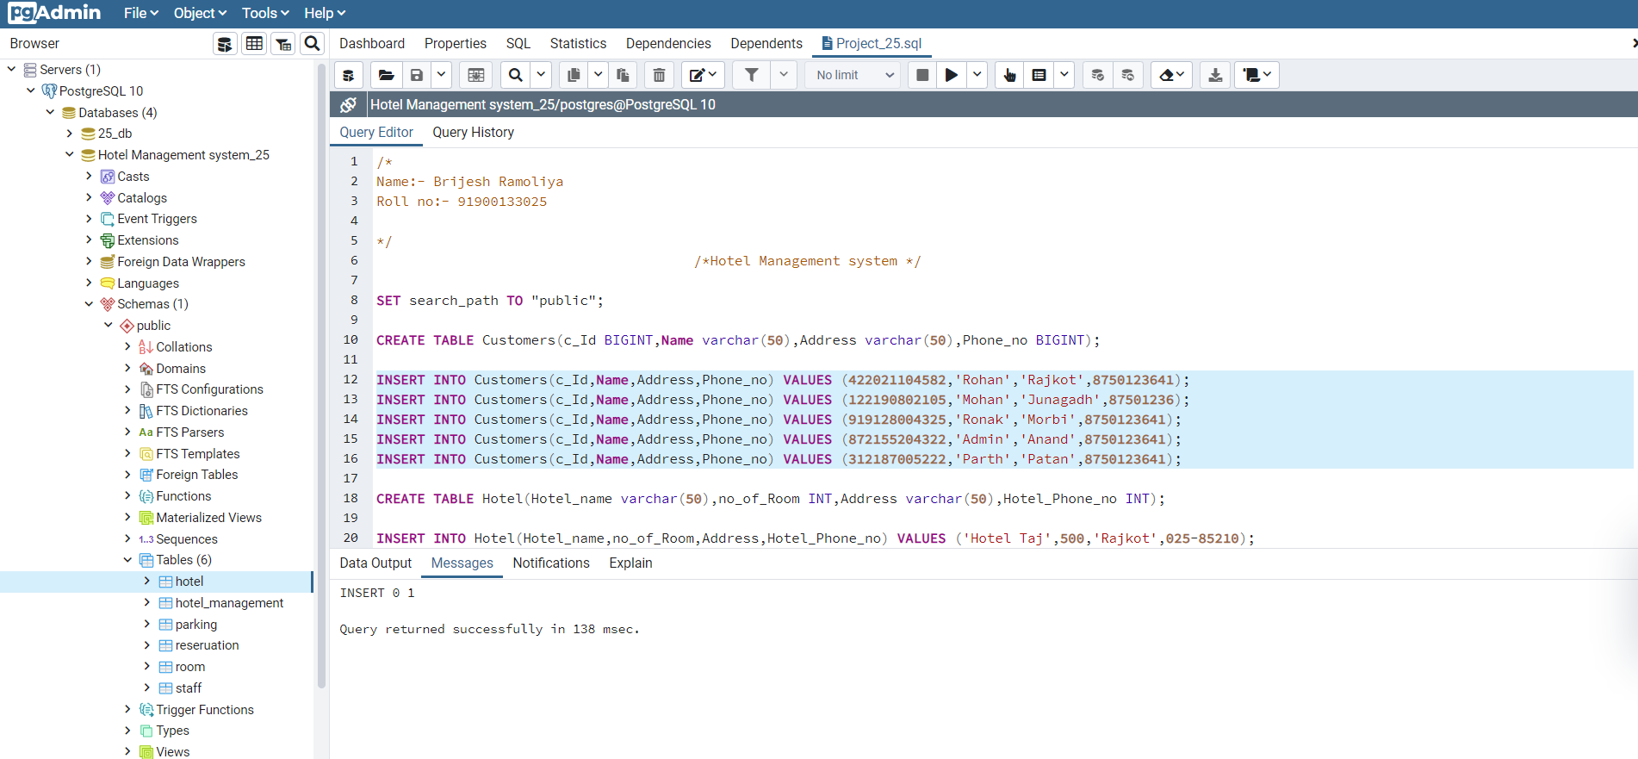

[2] Hotel

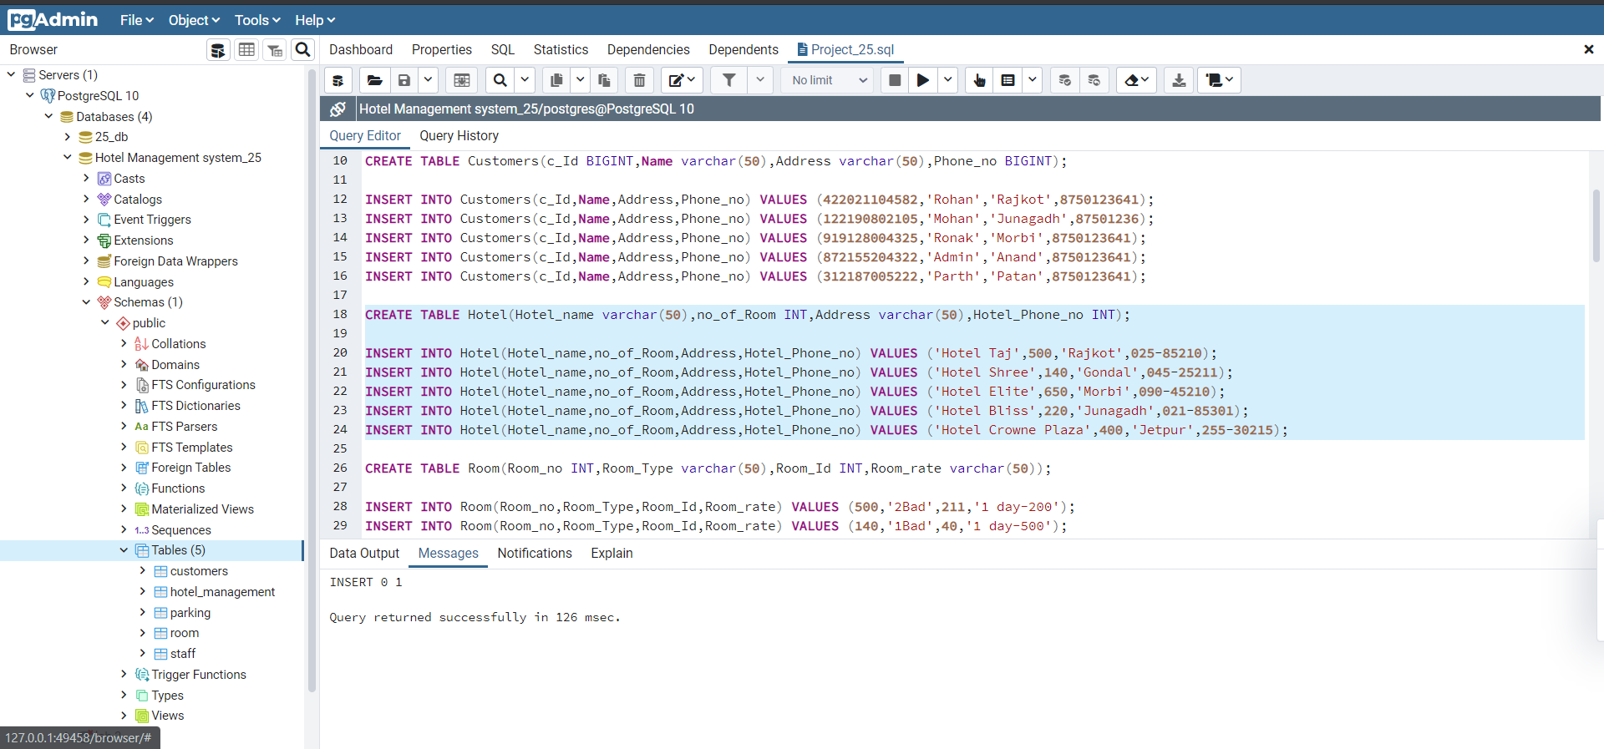

[3]Room

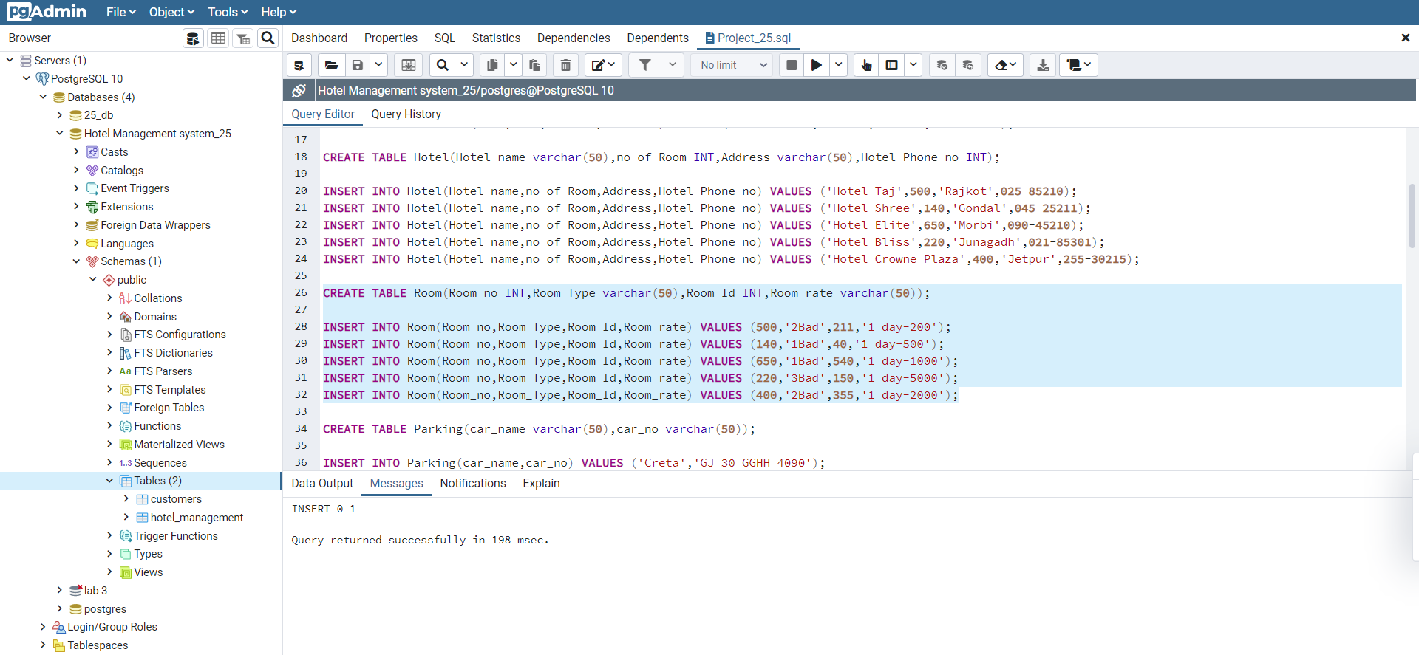

[4] Parking

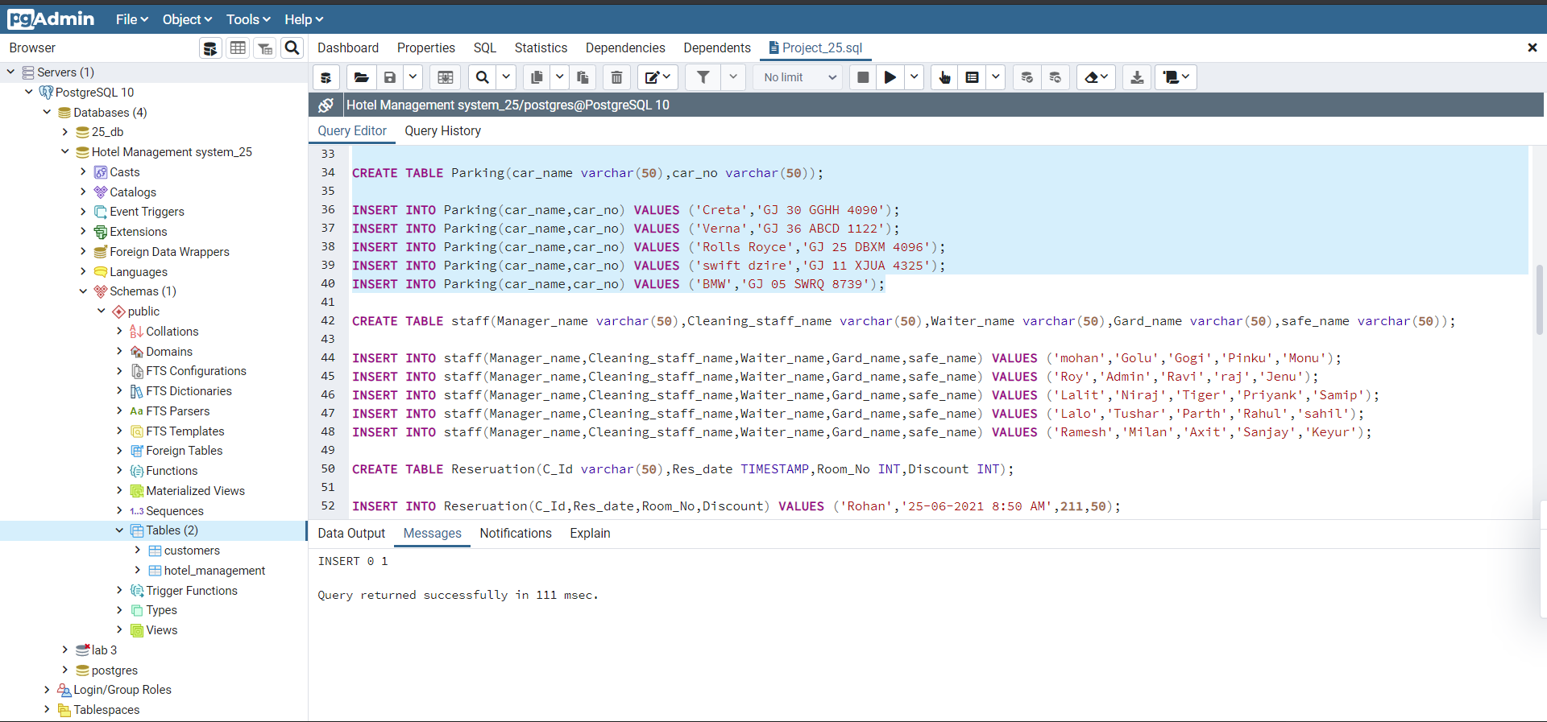

[5] staff

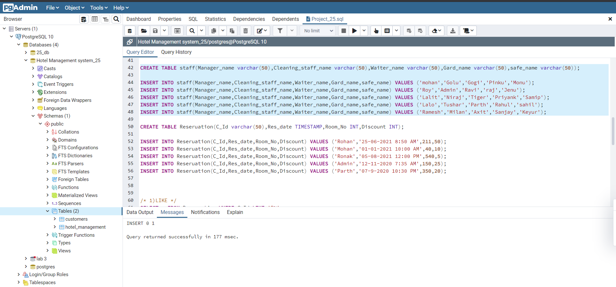

[6] Reseruation

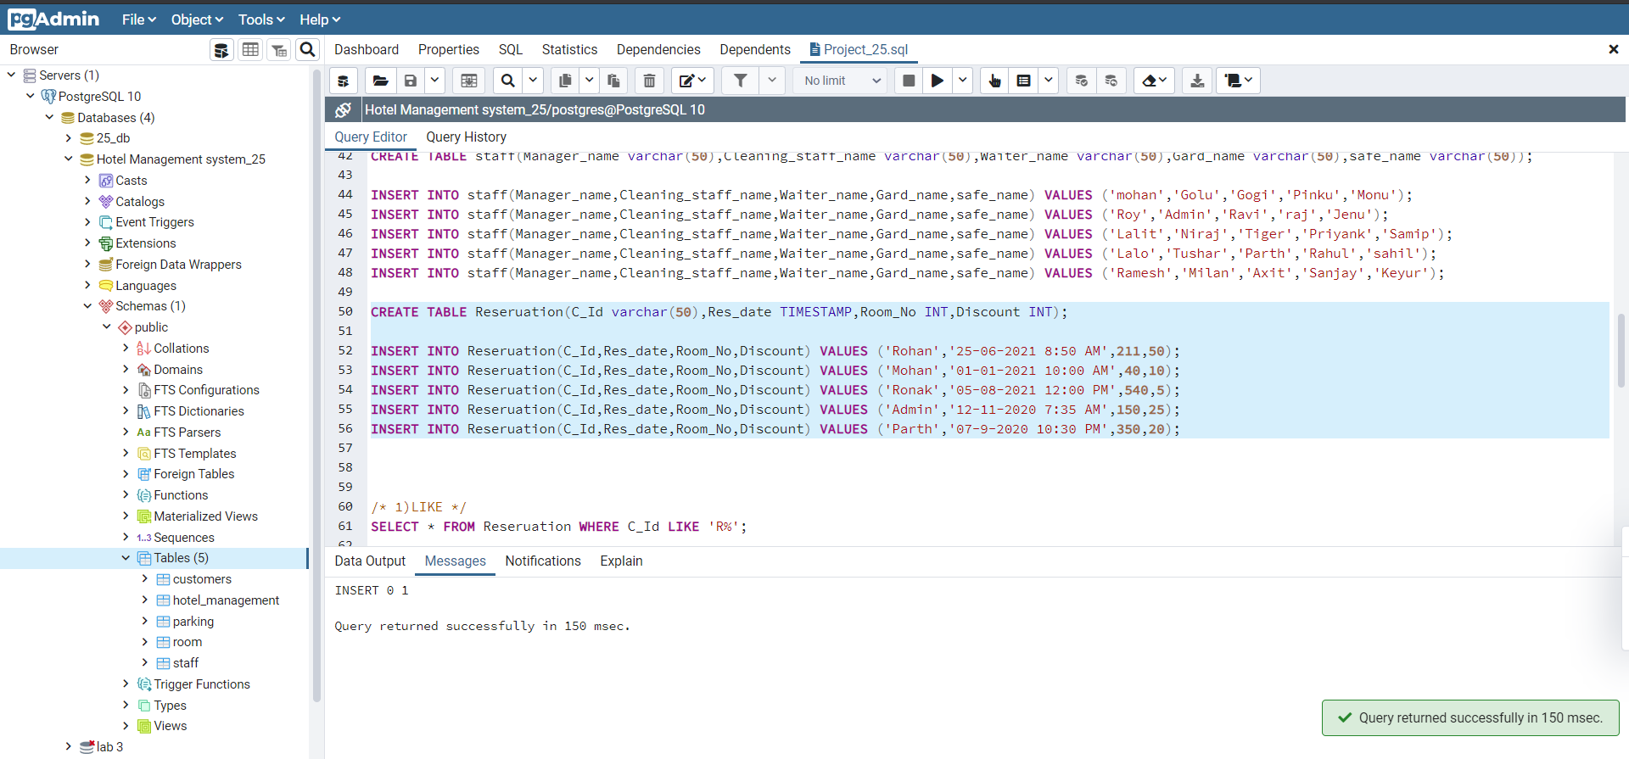

Queries:-

[1] LIKE

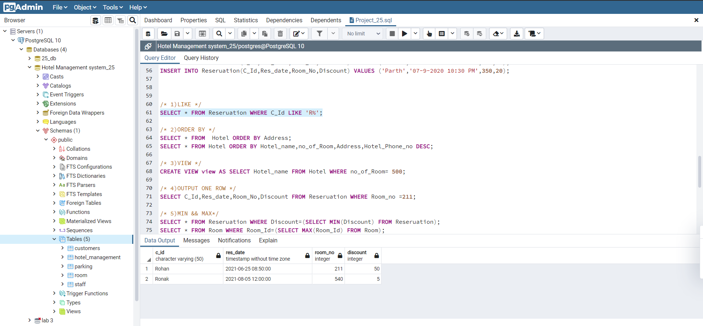

[2] ORDER BY

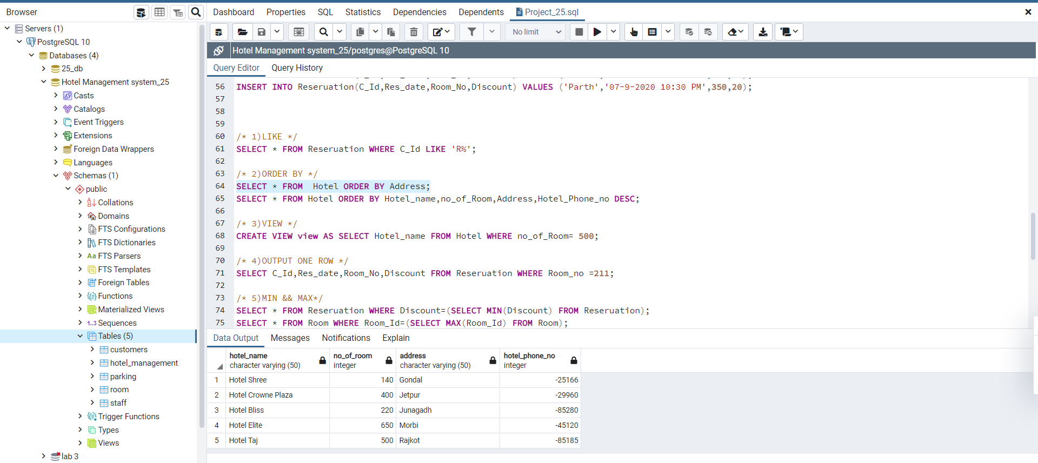

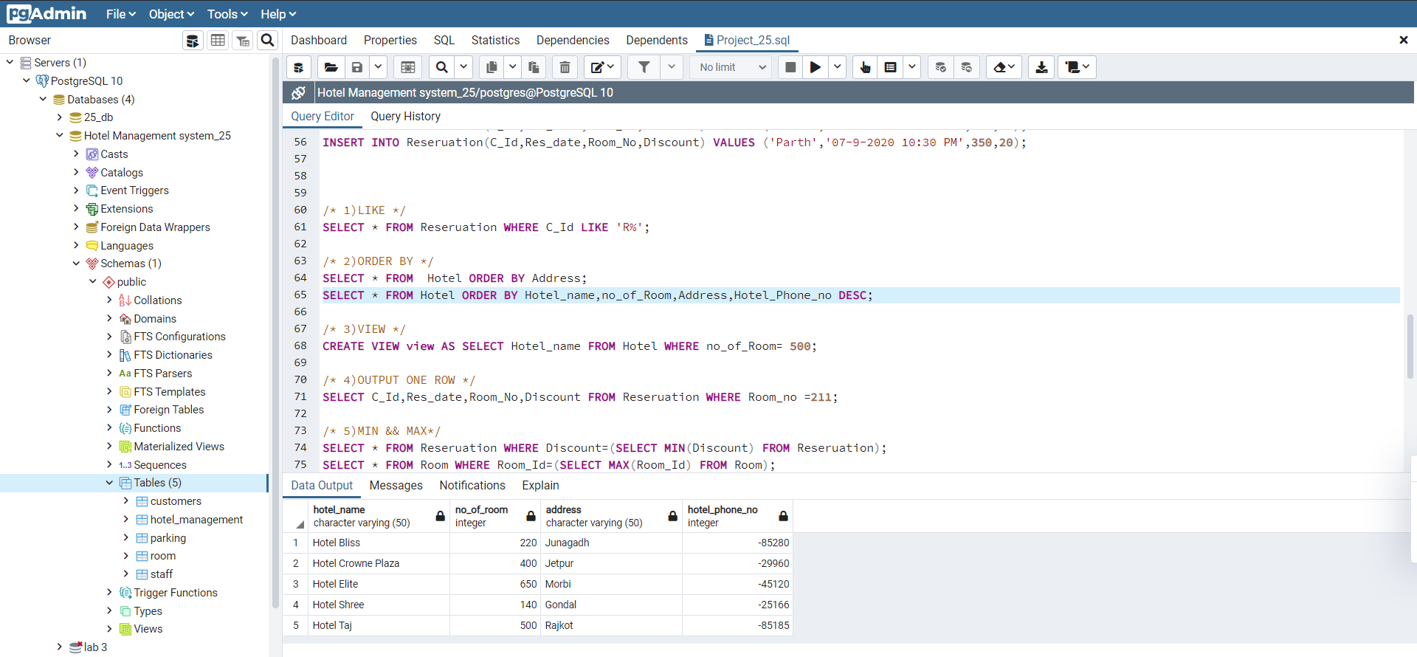

[3] VIEW

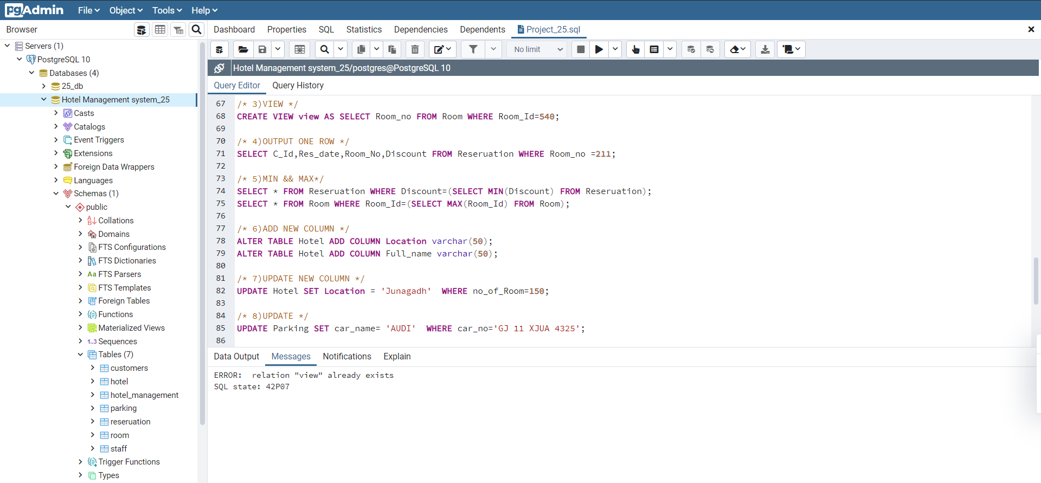

[4] OUTPUT ONE ROW

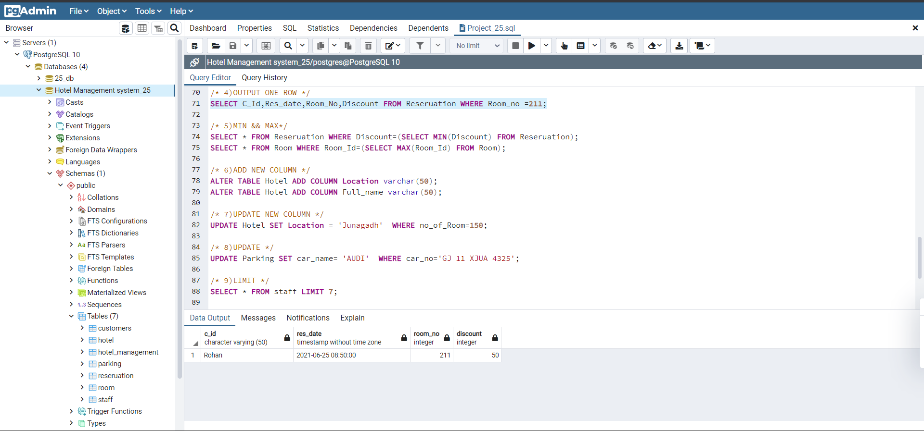

[5] MIN && MAX

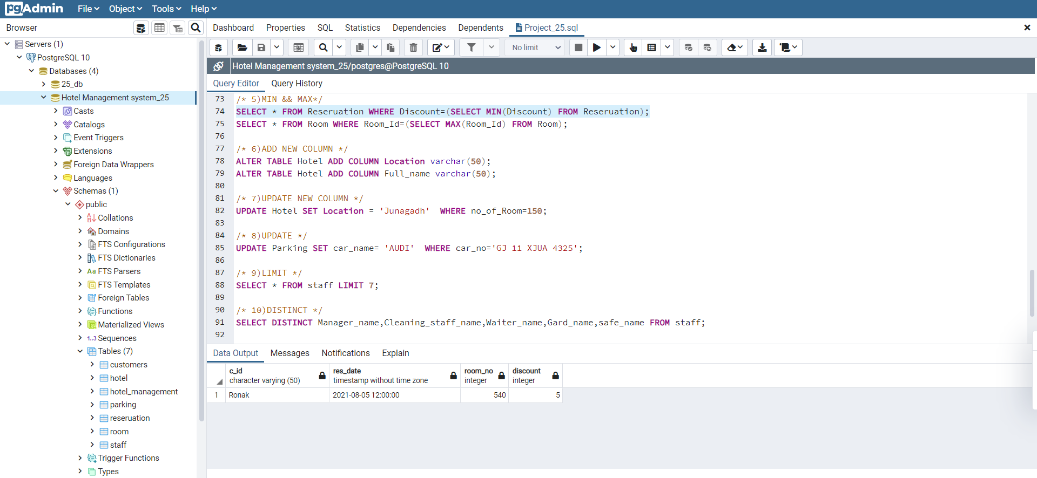

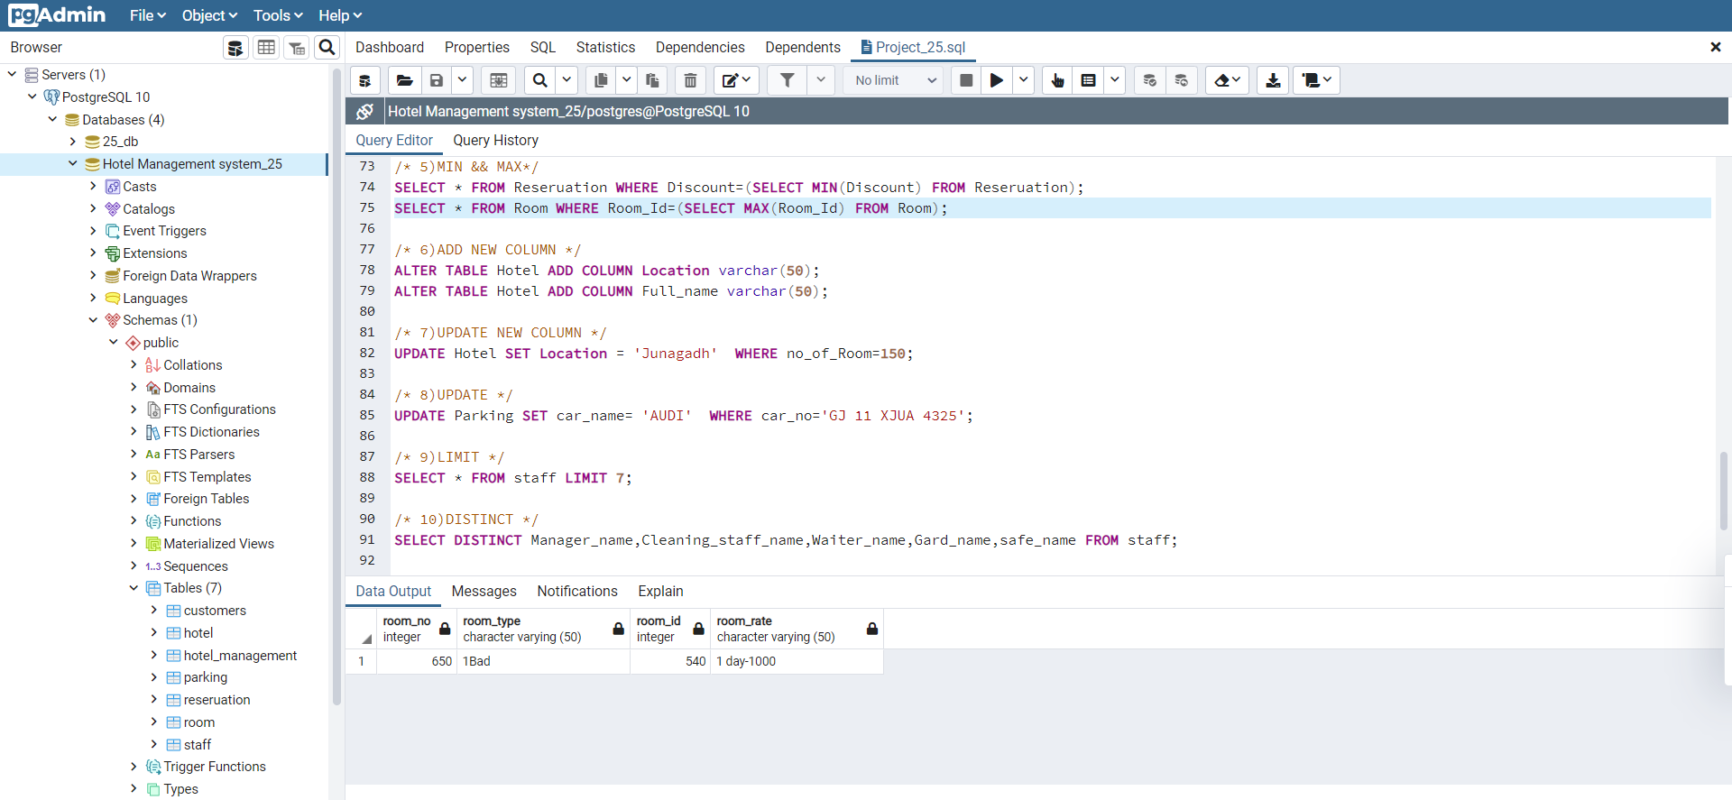

[6] ADD NEW COLUMN

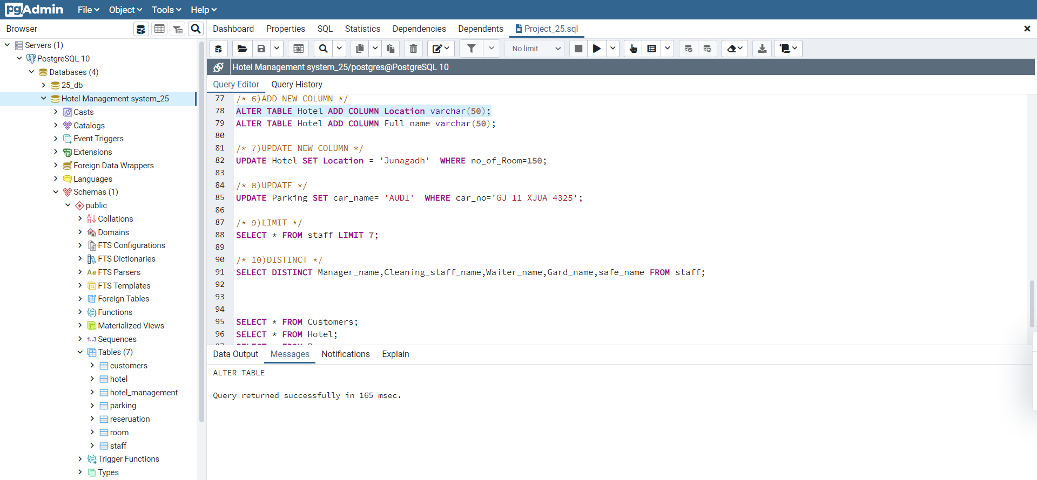

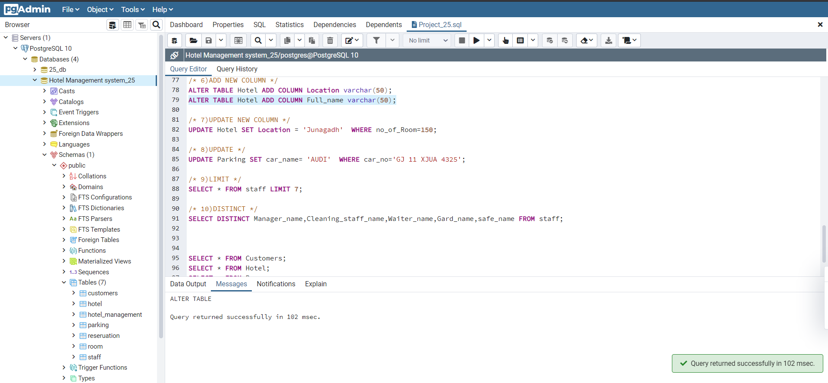

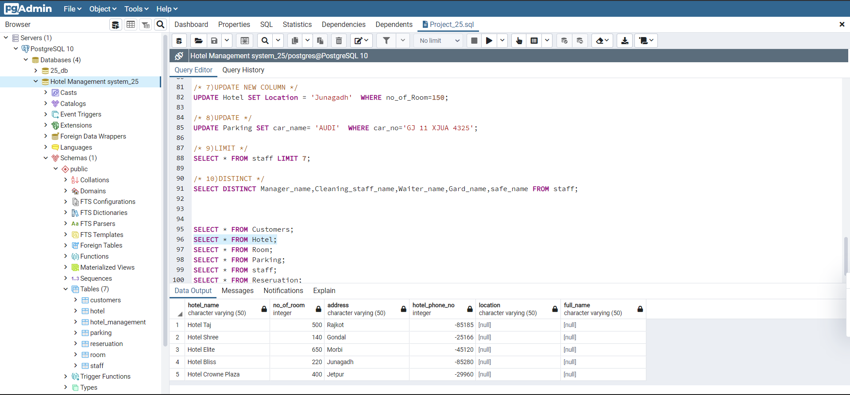

[7] UPDATE NEW COLUMN

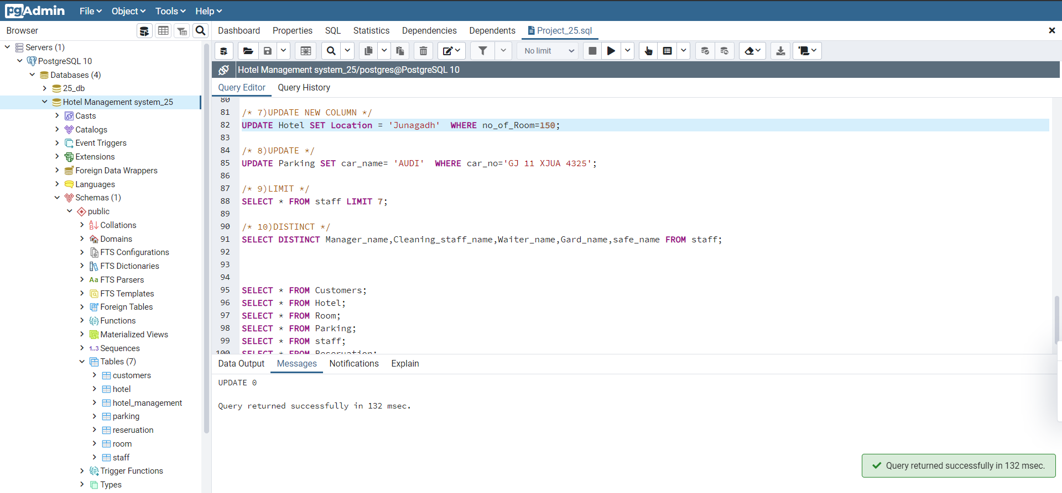



[8] UPDATE

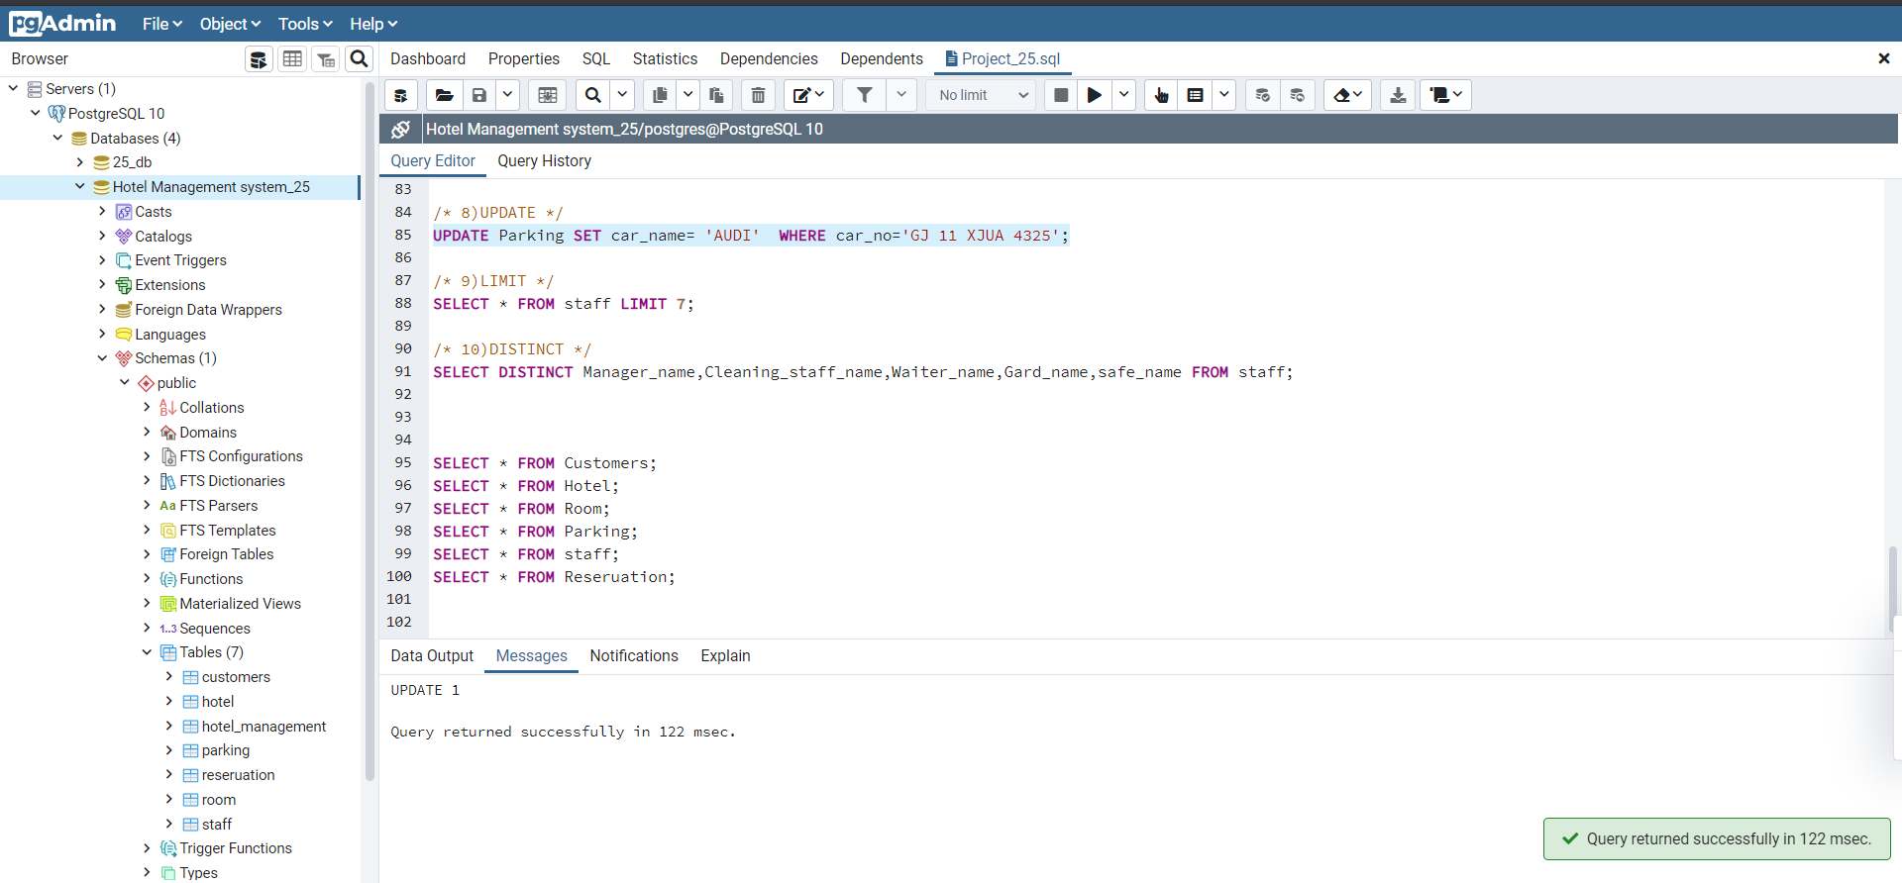

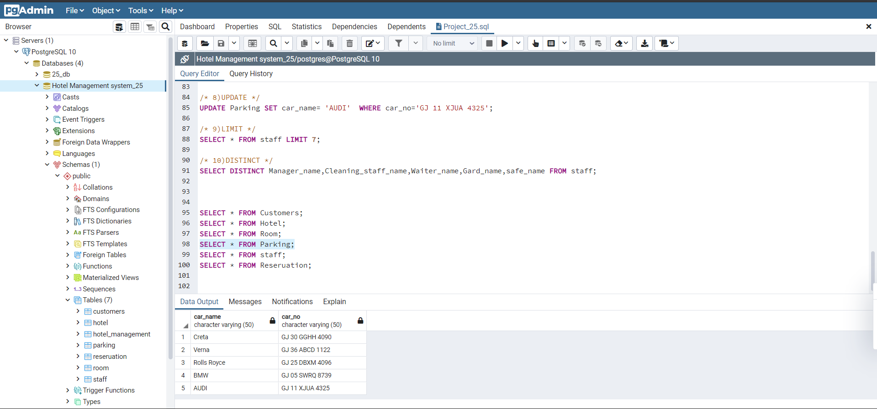

[9] LIMIT

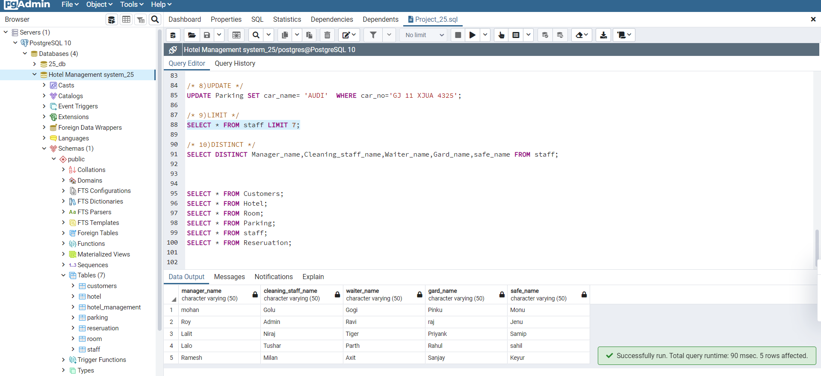

[10] DISTINCT

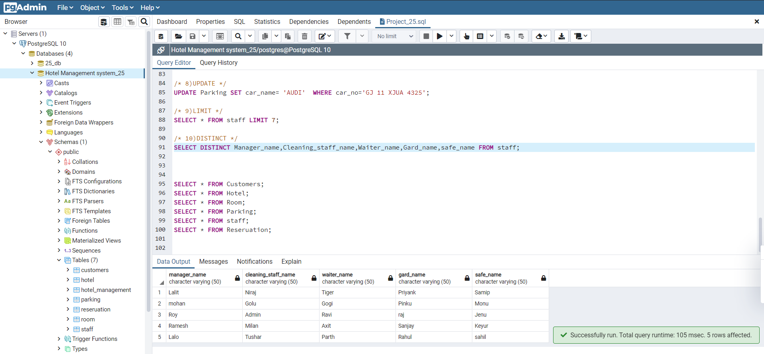

7) Conclusion.

* This Project Aims at create a Hotel Management System. I have a learn so many data type in input in database system. In this project is design to meet a requirement in all data input in one database. I have a learn many query in project. The Hotel Management system I have a created so many column in database. This project is not easy.